https://www.pes.edu/wp-content/uploads/2019/09/pes_logo.png

**END SEMESTER ASSESSMENT (ESA) B.TECH. (CSE)**

**IV SEMESTER**

**UE18CS256 – MICROPROCESSOR AND COMPUTER ARCHITECTURE LABORATORY**

**PROJECT REPORT**

**ON**

**Arduino NiMh Controlled Battery Charger with text display**

SUBMITTED BY

**NAME SRN**

1. **NIKHIL M A**

**PES2UG19CS257**

**PES2UG19CS258**

**PES2UG19CS264**

**PES2UG19CS263**

1. **NIKHIL VR**
2. **NISHANTH M**
3. **NISHANTH JC**

**JANUARY – MAY 2021**

**DEPARTMENT OF COMPUTER SCIENCE & ENGINEERING**

**ELECTRONIC CITY CAMPUS,**

**BENGALURU – 560100, KARNATAKA, INDIA**

|  |  |  |
| --- | --- | --- |
| TABLE OF CONTENTS | | |
| Sl.No | TOPIC | PAGE No |
|  | ABSTRACT OF THE PROJECT | 1 |
|  | CIRCUIT DIAGRAM | 2 |
|  | ARDUINO CODE | 5 |
|  | SCREEN SHOTS OF THE OUTPUT | 11 |
| 5. | REFERENCES | 14 |

**ABSTRACT OF THE PROJECT:**

The circuit design for this charger is a basic Arduino controlled power supply. The circuit is powered by a 5-volt regulated voltage source such as an AC adapter or an ATX computer power supply. Most USB ports would not appropriate for this project because of the current limitations. The 5V source charges the battery through a 10 ohm power resistor and a power MOSFET. The MOSFET sets how much current is allowed to flow into the battery. The resistor is included as an easy way to monitor the current. This is done by connecting each terminal to analog input pins on the Arduino and measuring the voltage on each side. The MOSFET is controlled by a PWM Output pin on the Arduino. The pulses of the pulse width modulation signal are smoothed out into a steady voltage signal by a 1M resistor and a 1 µF capacitor. This circuit allows the Arduino to monitor and control the current flowing into the battery.

As an extra precaution, we included a TMP36 temperature sensor to monitor the temperature of a battery. This sensor outputs a signal voltage that directly corresponds to the temperature. So it doesn’t require calibration or balancing like a thermistor does. The sensor is placed as close to the battery as possible to get the correct temperature reading. The pins of the sensor are then connected 5V, GND, and an analog input pin on the Arduino.

**CIRCUIT DIAGRAM:**

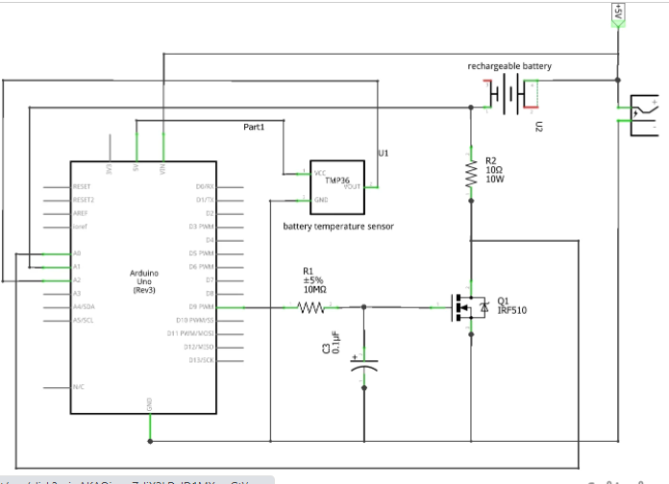 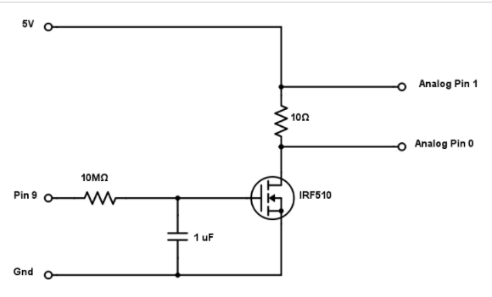

**ARDUINO CODE:**

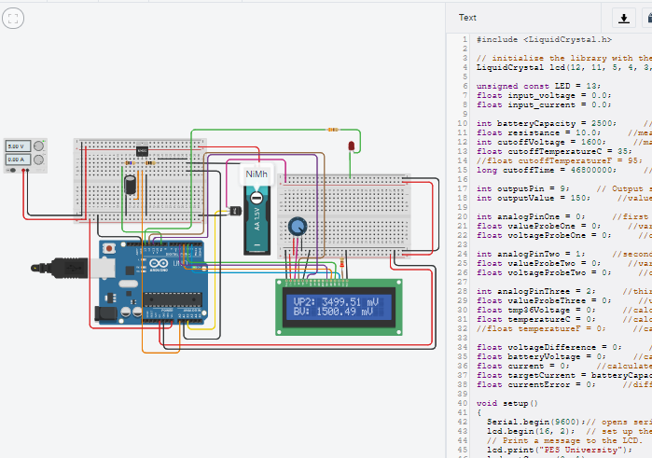

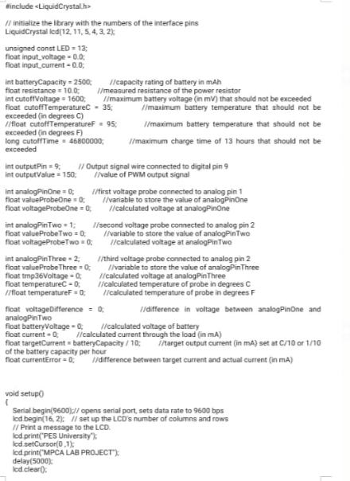

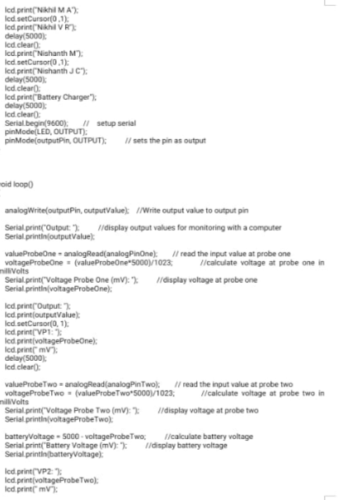

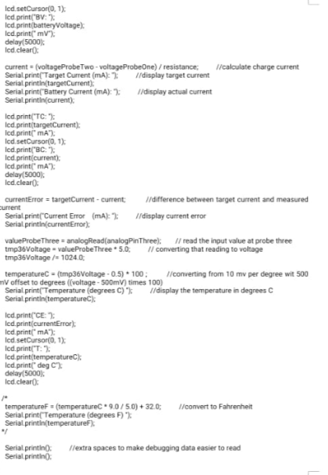

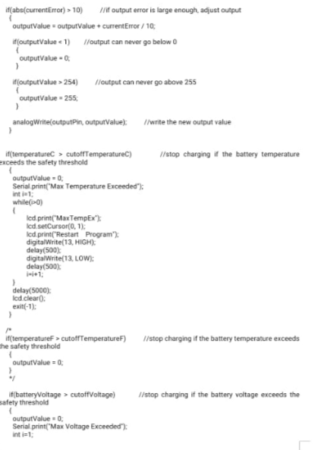

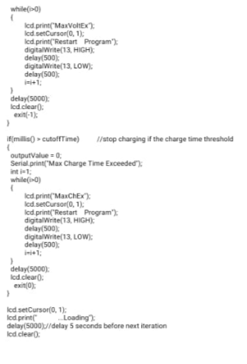

**SCREEN SHOTS OF THE OUTPUT:**

**Battery characteristics:**

1)Output

2)VP 1 – Voltage Probe 1

3)VP2 – Voltage Probe 2

4)BV – Battery Voltage

5)TC – Target Current

6)BC – Battery Current

7)CE – Current Error  
8) T – Temperature

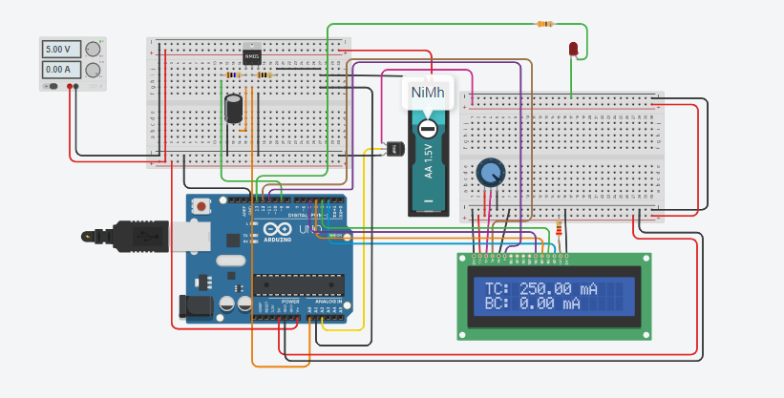

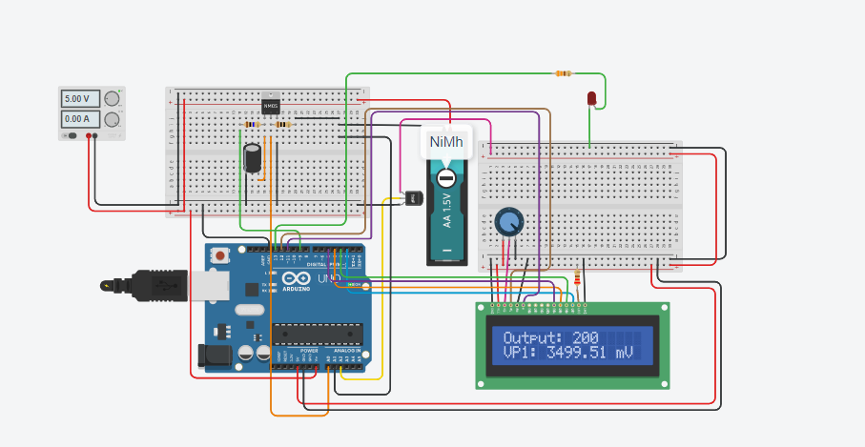

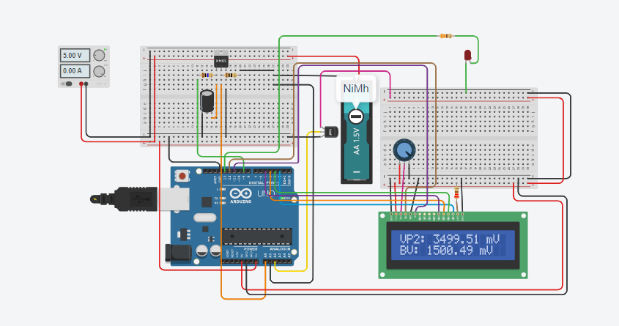

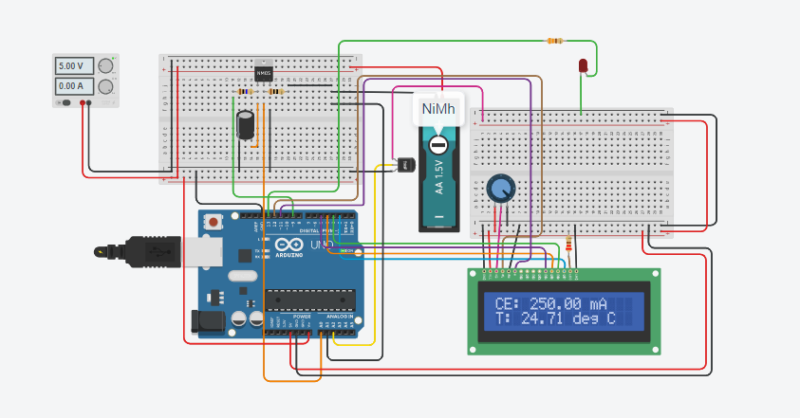

**LED is blinking since maximum voltage is exceeded.**

**The LCD screen displays the message prompting user to restart the program.**

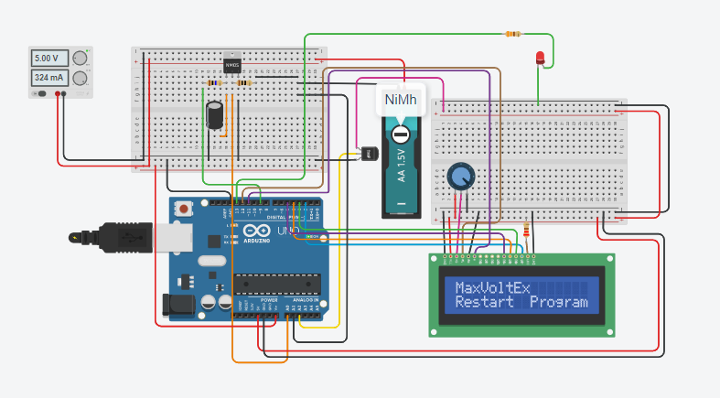

**REFERENCES**

**Our Project is made public on tinkercad and this is the link where one can access it.**

**Link->** [**https://www.tinkercad.com/things/imSwDhu70jK-mpca-project-nimh-controlled-battery-charger-with-text-display**](https://www.tinkercad.com/things/imSwDhu70jK-mpca-project-nimh-controlled-battery-charger-with-text-display)

**If link does not work, under public circuits, enter the keywords-> MPCA Nimh and the first project is our project**